Your name: Bryan

- Objective
- What question does this experiment answer / what hypothesis does it test?
Ans: This experiment tests whether a non-linear gradient boosting model (LightGBM) predicts local GVA outcomes better than the OLS baseline (Experiment 1), using the same 11 DAG features and held-out test set.
Research question: Can LightGBM improve prediction of log GVA (total output, productivity, and 2025 forecast) from SME structure, economic resilience, employment, and controls?

Hypothesis: If relationships between predictors and GVA are non-linear or involve interactions, LightGBM should achieve higher test R² than OLS; if the data are largely linear, gains should be small.
- Method
- Model name:LightGBM
- Key hyperparameters / settings:
n_estimators=500, learning_rate=0.05, num_leaves=31, max_depth=-1
min_child_samples=20, subsample=0.8, colsample_bytree=0.8
random_state=42, verbose=-1
• Data: train_updated.csv (900 rows) / test_updated.csv (221 rows); 0 missing values
• Features (11): same DAG set as Exp 1 (business structure, resilience, employment, urban/rural, population, IMD)
• Targets (3): log_total_GVA_2023, log_gva_per_worker_2023, log_GVA_2025_predicted

- Evaluation approach: Fit on train only; evaluate on test
- Please provide 1-2 papers related to your experiment
- Paper’s name: LightGBM: A Highly Efficient Gradient Boosting Decision Tree
- Paper’s Bib:
@inproceedings{ke_lightgbm_2017,
title = {{LightGBM}: {A} {Highly} {Efficient} {Gradient} {Boosting} {Decision} {Tree}},
volume = {30},
url = {https://proceedings.neurips.cc/paper_files/paper/2017/file/6449f44a102fde848669bdd9eb6b76fa-Paper.pdf},
booktitle = {Advances in {Neural} {Information} {Processing} {Systems}},
publisher = {Curran Associates, Inc.},
author = {Ke, Guolin and Meng, Qi and Finley, Thomas and Wang, Taifeng and Chen, Wei and Ma, Weidong and Ye, Qiwei and Liu, Tie-Yan},
editor = {Guyon, I. and Luxburg, U. Von and Bengio, S. and Wallach, H. and Fergus, R. and Vishwanathan, S. and Garnett, R.},
year = {2017},
}
4. Results — facts only, no interpretation
- Metric values (paste ): 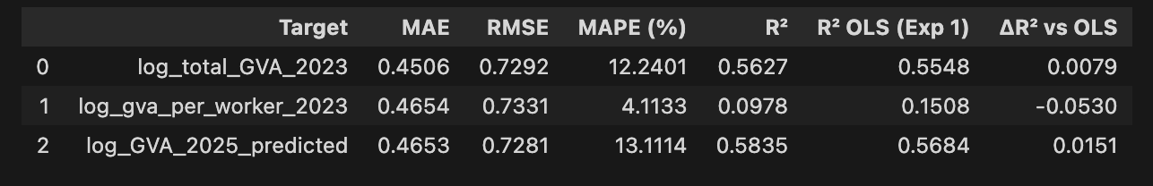
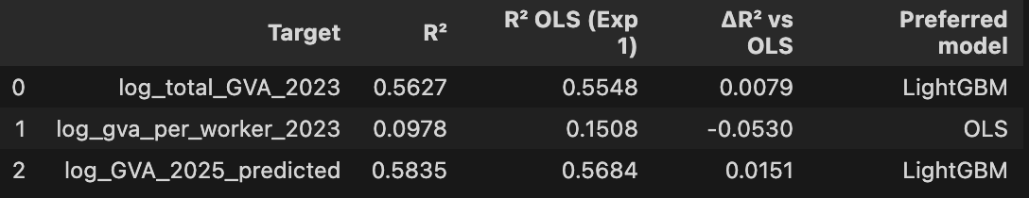
- Key figures/charts (embed or link):
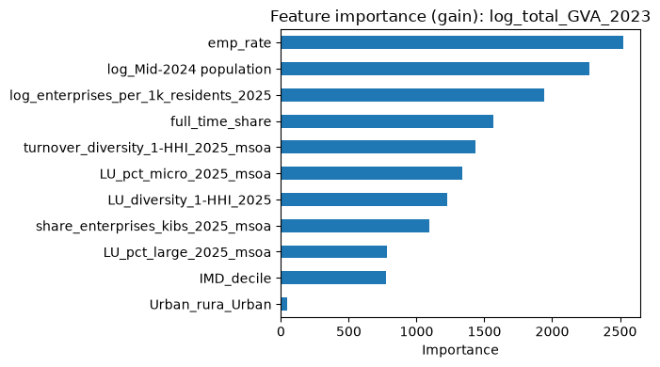
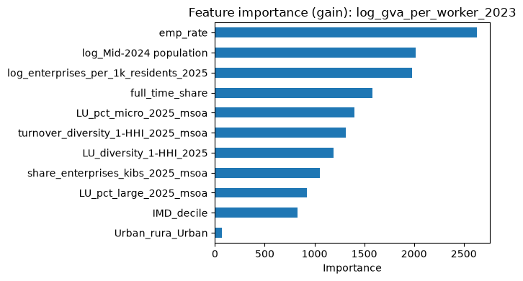
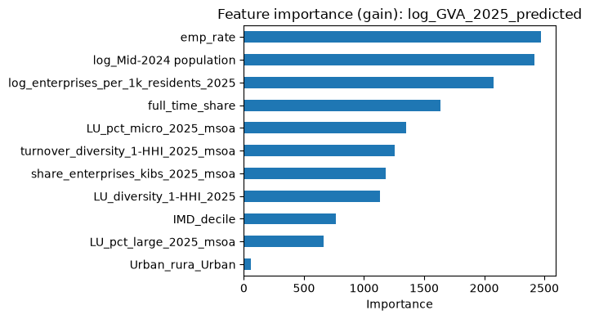
5. Discussion — your judgement
- What does this result show?
Ans: LightGBM gives modest improvements over OLS for total GVA and 2025 predicted GVA on the full test set (R² +0.008 and +0.015; MAE and RMSE slightly lower on all three targets). For productivity (log_gva_per_worker_2023), LightGBM is worse (R² 0.098 vs 0.151). So a more flexible tree model helps some outcomes but not all. Overall fit stays moderate (R² ~0.56–0.58 for total/2025 GVA; productivity remains weak for both models).

- How does it compare to the literature / the previous experiment?
Ans: Exp 1 OLS already explained most test variance for total and 2025 GVA (~55–57%). Exp 2 adds small R² gains, which fits LightGBM often giving incremental gains when relationships are mostly linear or the feature set is small. Productivity was hard in Exp 1 (R² 0.15); LightGBM does not fix that and performs worse — extra flexibility may overfit noise on a harder target. On non-hub LSOAs (emp_rate ≤ 1), LightGBM R² (0.402) is slightly below OLS (0.408), so boosting does not clearly improve robustness there either.
- Anomalies / surprises:
LightGBM loses to OLS on productivity despite being more flexible.
Swindon test R² is much higher than full-sample R² for total GVA (0.73 vs 0.56), but Swindon n = 18 — that gap may reflect small-sample volatility, not true generalisation.
- Error metrics (MAE/RMSE) improve slightly even where R² falls, so ranking by R² alone can look different from ranking by absolute error.

6. Reflection
- Planned approach vs. what was actually done:
Ans: Planned ---- mirror Exp 1 (same data, features, targets, metrics) but swap OLS for LightGBM with fixed hyperparameters; add predicted-vs-actual plots, feature importance, OLS comparison, Swindon portability, and non-hub check. That is what was done in experiment2_lightgbm.ipynb. Evaluation helper and training loop were written manually rather than copied from a template.
- Limitations / uncertainties:
No hyperparameter tuning or cross-validation — settings are defaults, not optimised.
Mixed years: 2025 features vs 2023 GVA targets.
Live vs work: emp_rate can exceed 1 (commuter hubs); non-hub check only covers one target.
Small Swindon test set (18 LSOAs) limits portability conclusions.
Feature importance (gain) is descriptive, not causal.
Train/test are regional LSOAs, not a strict random split of Swindon only.
- Next steps:

